

User

documentation

DTMs

Document Trace Manager

Made by: Serena Kenter

Date: 18-01-2024

1. Introduction 1

2. Authentication 2

2.1. Login 3

2.2. Forgot password 3

2.3. Code 3

2.4. New password 4

3. Documents 4

3.1. Overview 5

3.2. Extra info 5

3.3. Upload 5

4. Employees 6

4.1. Overview 7

4.2. Loan history 7

4.3. Upload 7

5. Products 8

5.1. Overview 9

5.2. Extra info 9

5.3. Return product 9

5.4. Upload 10

6. Profile 10

6.1. Personal data 11

6.2. Edit data 11

6.3. Change password 11

6.4. Manage users 12

# Introduction

The original assignment arose in response to the organization's growth, revealing various issues. The primary concern was the inefficiencies stemming from manual processes, particularly in managing a substantial volume of documents such as passports, contracts, and user agreements. These processes consumed significant time and often led to errors and overlooked tasks, posing obstacles to smooth operations and potential legal and operational complications.

The impetus for the assignment arose from the urgent need to address these issues and enhance operational efficiency. The ultimate goal was to develop a customized application specifically focused on generating alerts as the expiration dates of critical documents approached. The aim was to timely inform relevant employees about upcoming expiration dates, enabling them to take appropriate measures to maintain the validity of these documents.

The initial scope of the assignment included developing the document management application and the alert generation feature. However, beyond the original scope of the assignment, additional functionalities related to employee overviews, loan overviews, and linking employees to borrowed items, including the history of these transactions, were added.

The additional requirements for employee and loan management expanded the scope of the assignment. Now, the application had to support not only document management but also provide complex functionalities for tracking employees, their borrowed items, and the history of these interactions.

The intended outcome is a comprehensive web application that meets the original needs of document management and alert generation while also fulfilling the new requirements for employee and loan management. This is expected to significantly enhance operational efficiency and provide a comprehensive solution to the challenges arising from the organization's growth. The choice of a web application ensures broad accessibility, flexible scalability, and sustainability, meeting the expectations of all stakeholders within the organization.

This document will be focust on the interface of the application. It will show the way to use it and the possabilities of this application.

# Authentication

## 2.1. Login

This is the login page where an email and password are required. You're not able to register because only 4-rest employees from the MT should be able to access the website. When logged in you can edit users in the profile page if necessary.

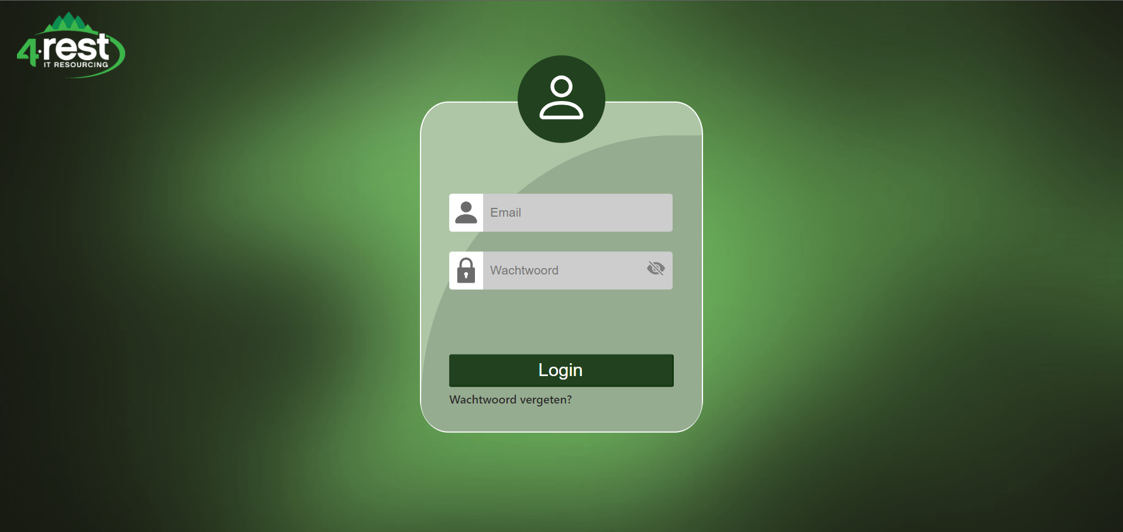

## 2.2. Forgot password

When the button “Wachtwoord vergeten” is pushed, the following screen will appear. You need to fill in the email which is linked to an account.

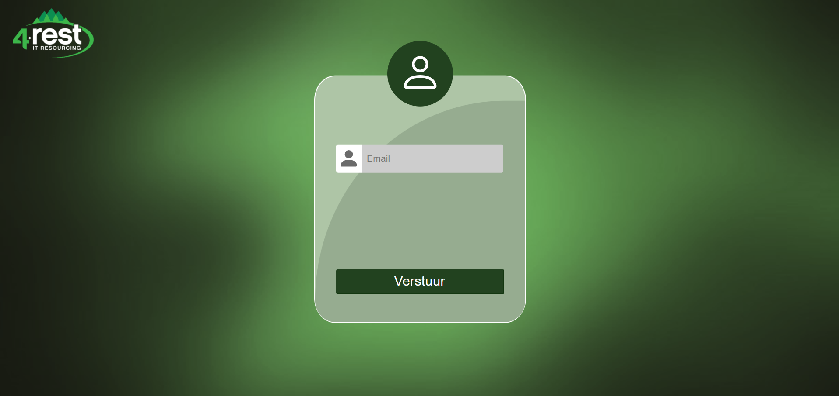

## 2.3. Code

When you hit the “Verstuur” button, you’re getting a code sent to your email. Paste this code into the required field and hit the “Verander wachtwoord” button. If the code is correct, you will be sent to the following page.

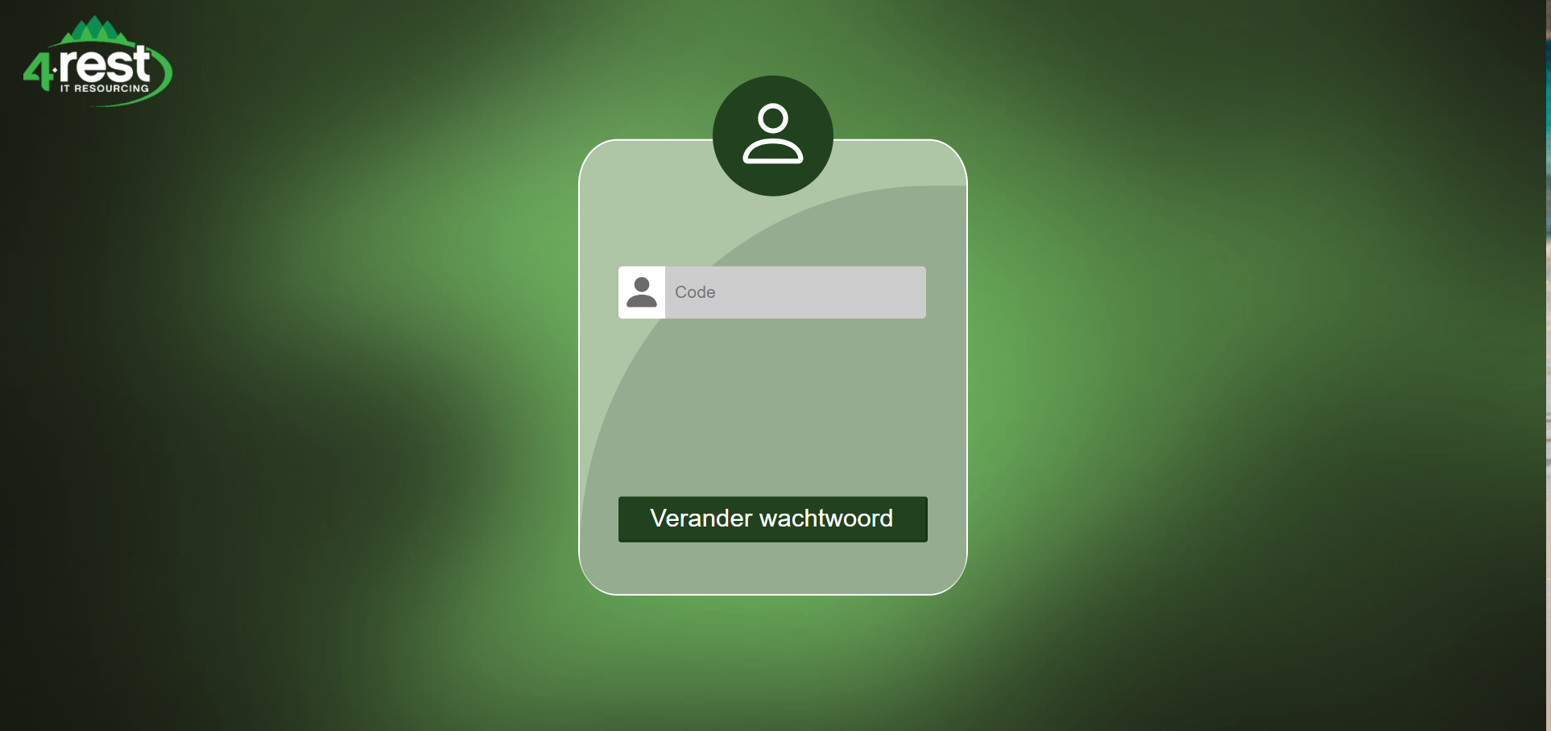

## 2.4. New password

At this point you can create a new password for your account. If you hit the “Opslaan” button you will be sent to the login page, and you can login with your new password

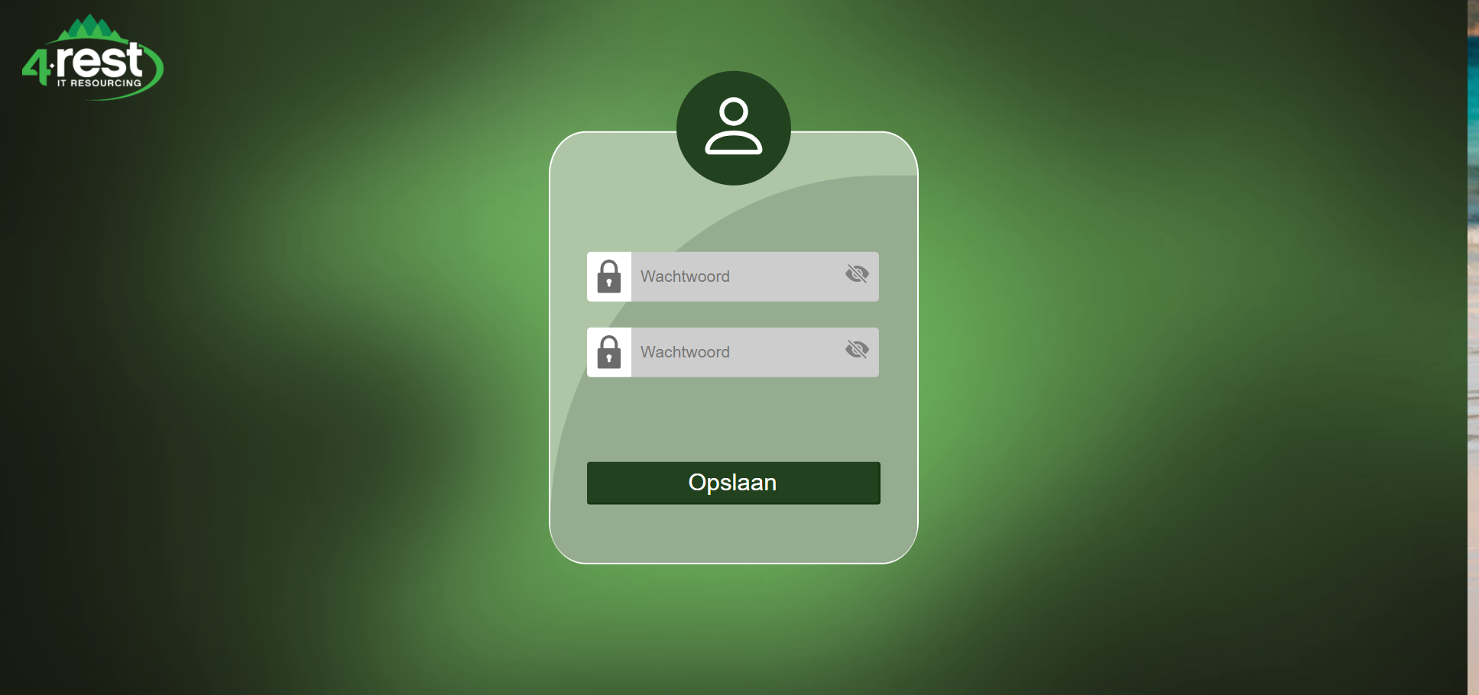

# Documents

## 3.1. Overview

When you're logged in, this is the first page you see. From here you can go to the archive, to see all archived documents. When documents are placed in the archive, they can be deleted fully from the server. You can also go to the documents which are valid longer than 6 weeks.

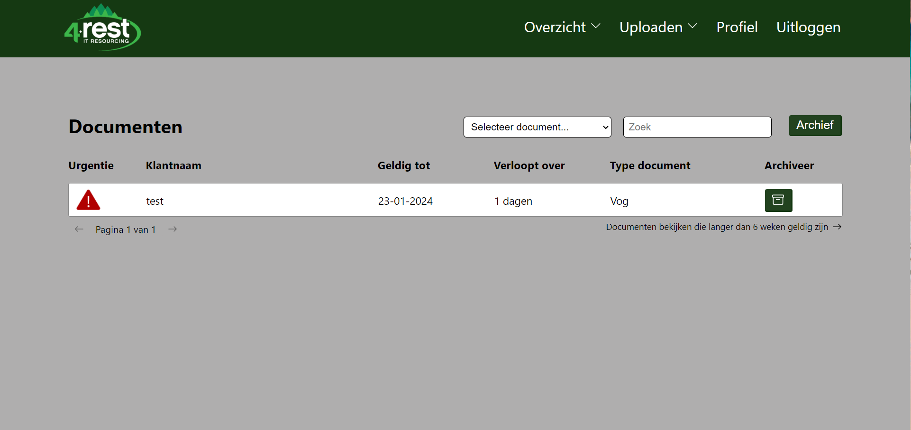

## 3.2. Extra info

When you click on the document, you can see more detailed information and edit it.

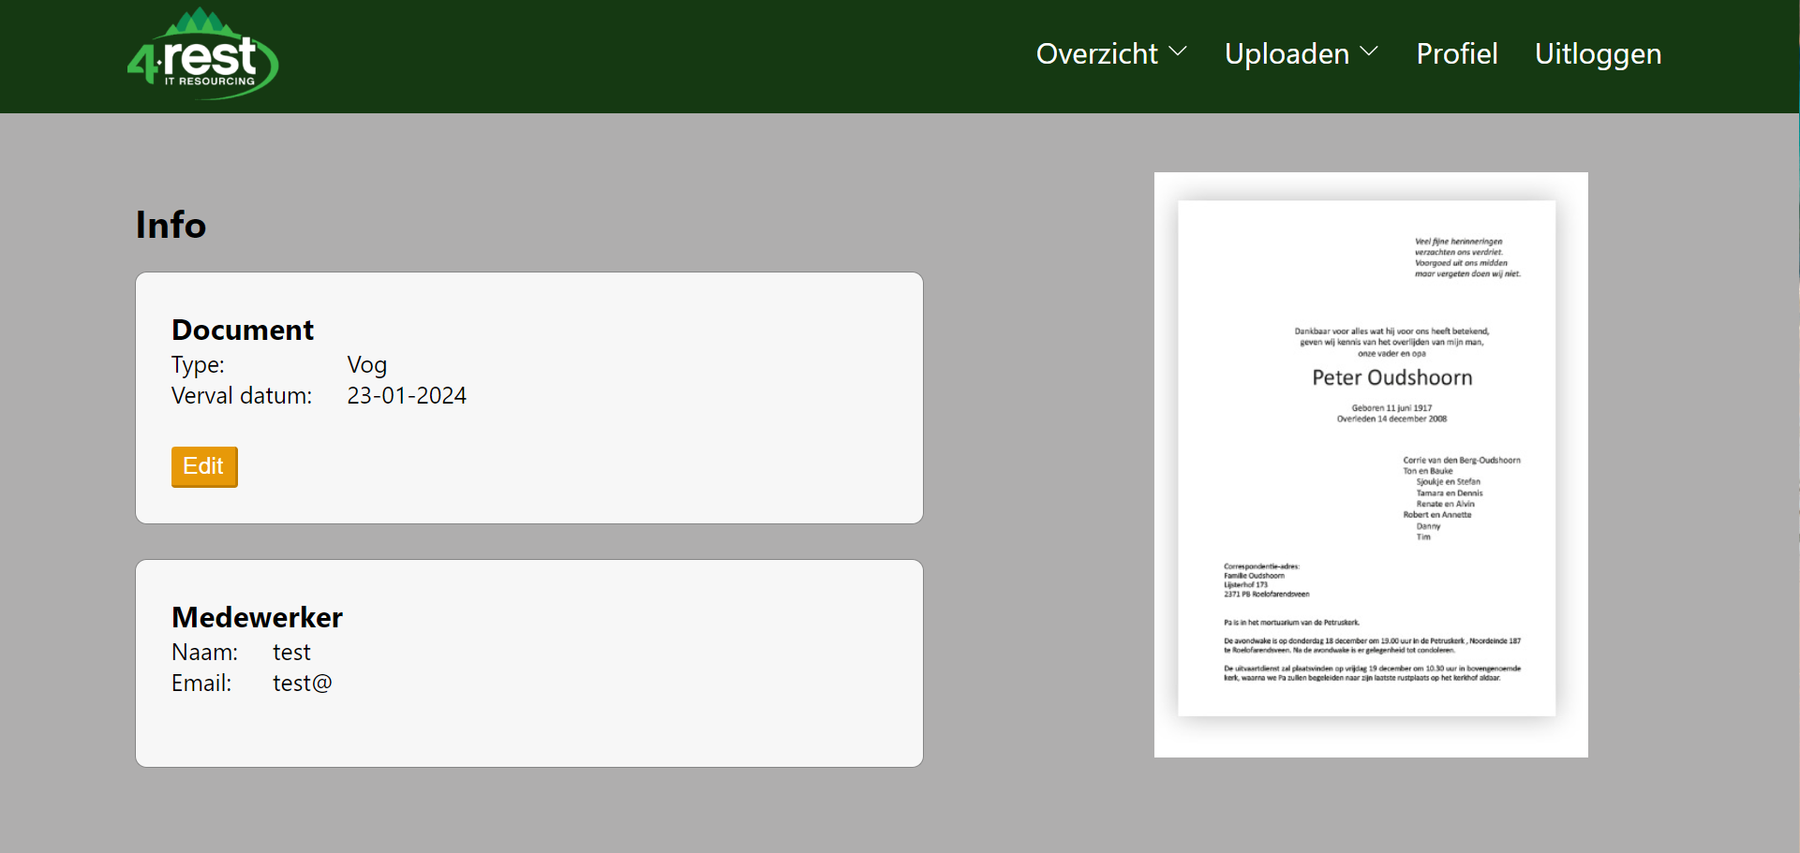

## 3.3. Upload

The following image shows where you can upload the documents. To get here you need to hover over "Uploaden" and click on "Document".

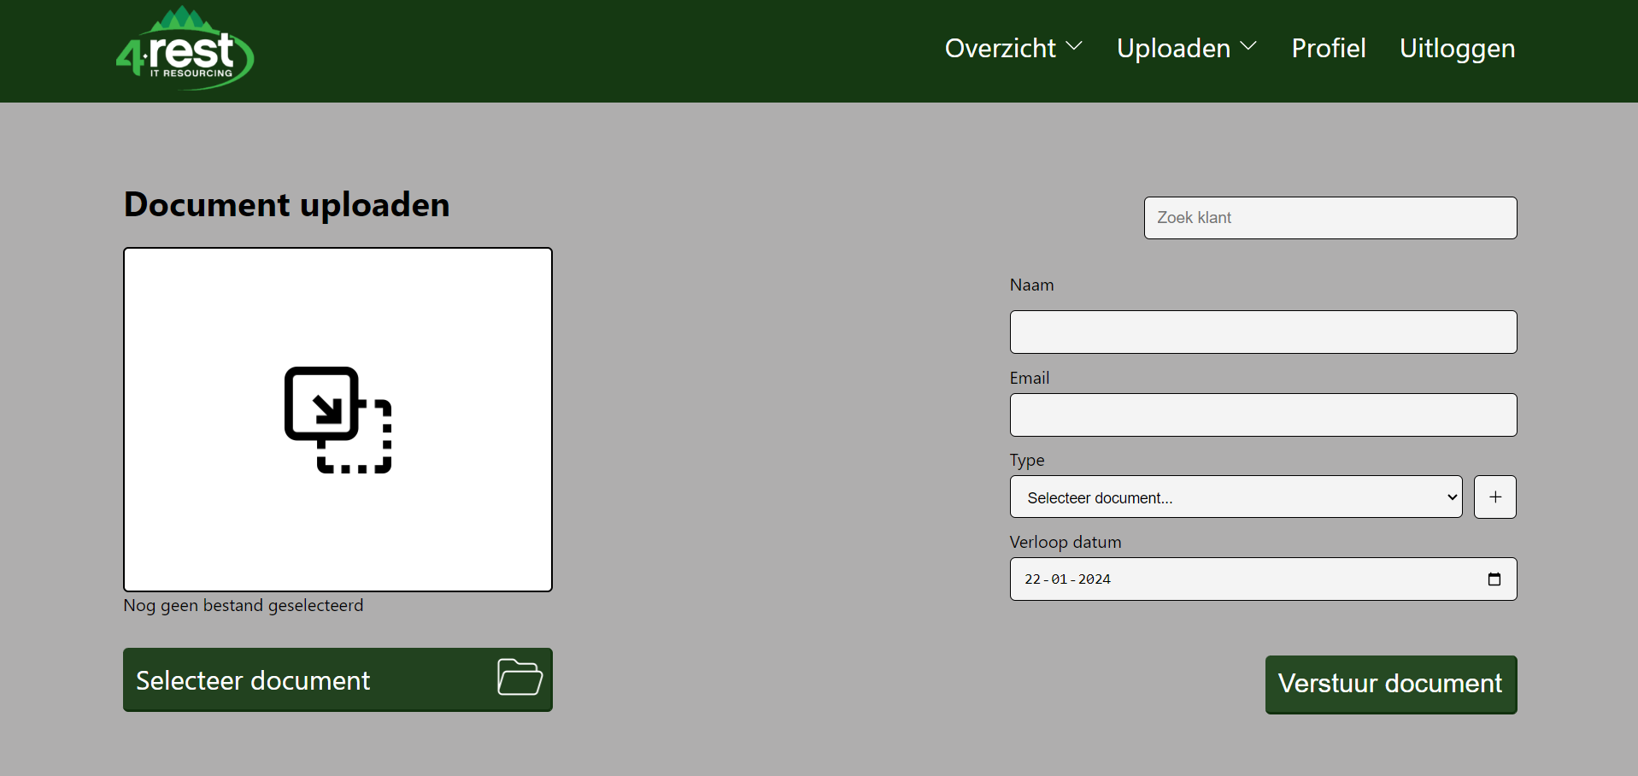

# Employees

## 4.1. Overview

This is the employee overview. To get here you need to hover over "Overzicht" and click on "Medewerkers". This overview also has an archive where you can delete the employees. When you click on the employee you also get to see more information. In addition, when you click on the "Geschiedenis" button you can see the history of borrowed products per employee. You can see this in the next 2 images.

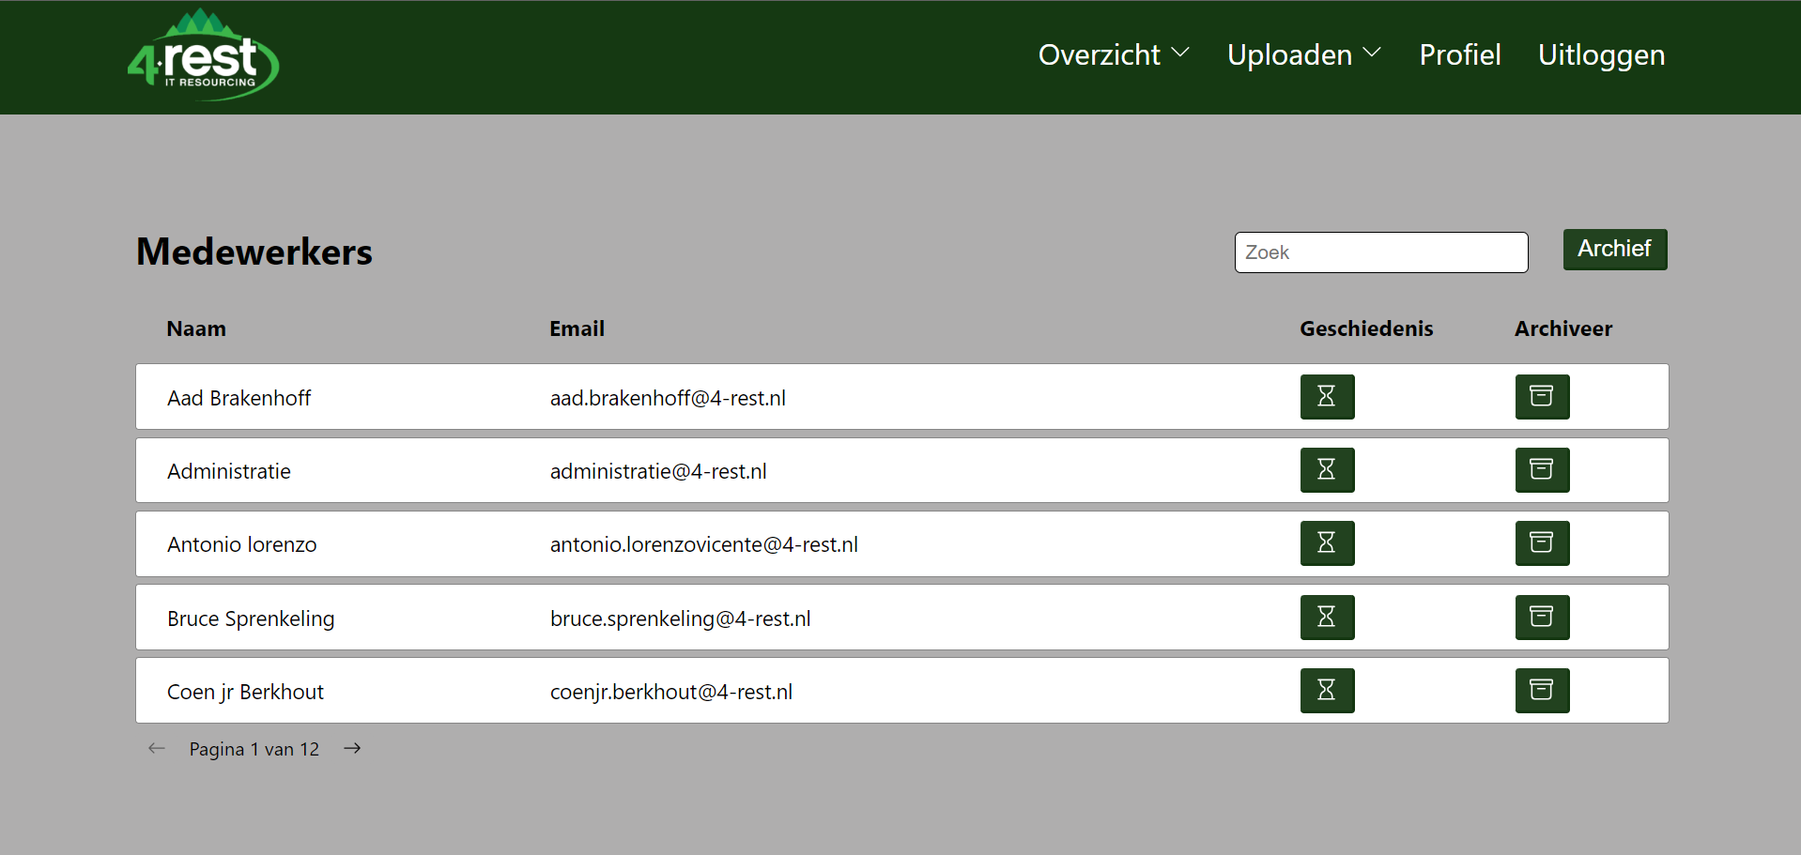

## 4.2. Loan history

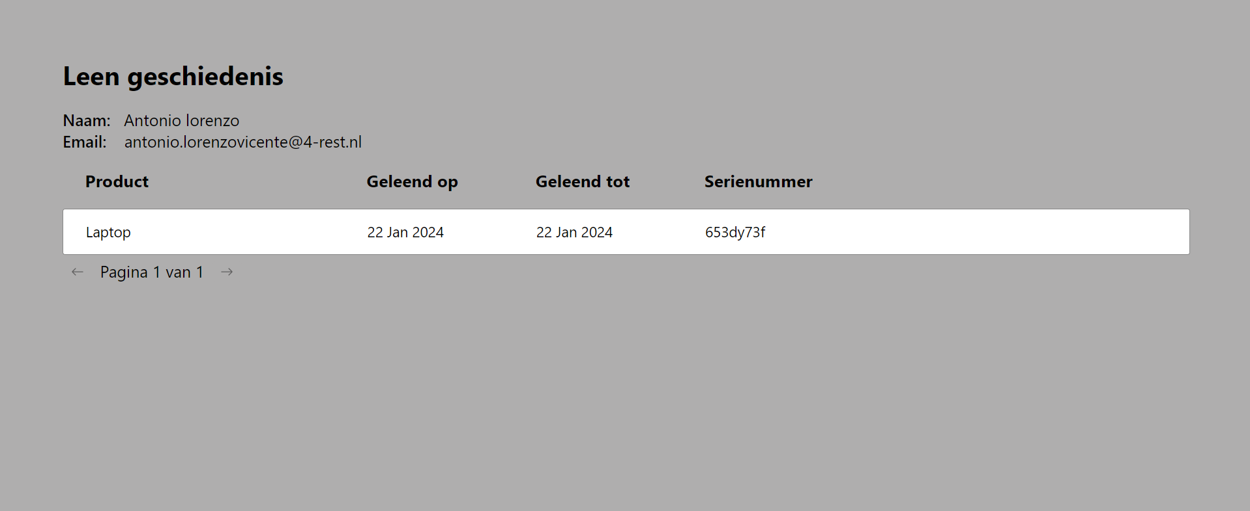

## 4.3. Upload

The following images shows where you can upload new employees. To get here you need to hover over "Uploaden" and click on "Medewerker".

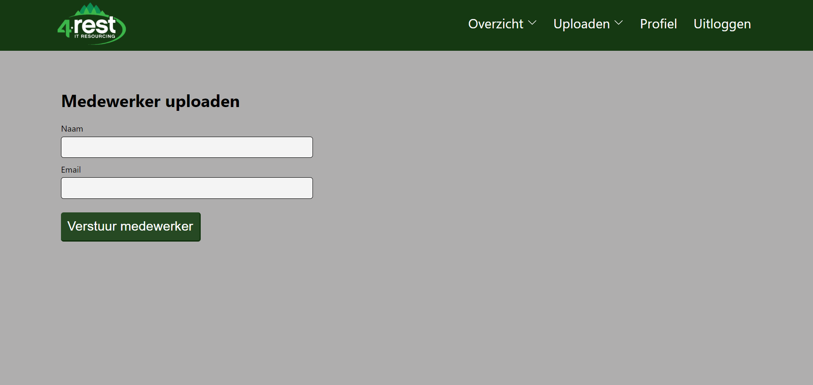

# Products

## 5.1. Overview

This is the overview of products. To get here you need to hover over "Overzicht" and click on "Bruikleen". Here you can also see the history of the products and click on the product to see more info. Instead of an archive, a trashcan is implemented which means that if a product is placed in the trashcan, it will automatically be deleted after 3 months.

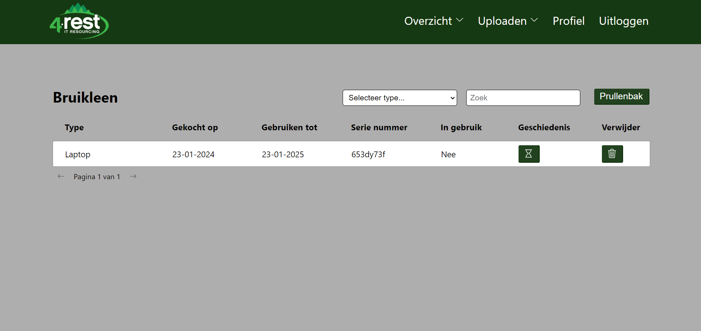

## 5.2. Extra info

In this info page you can lend a product to an employee. To lend it you enly need to click on the right employee.

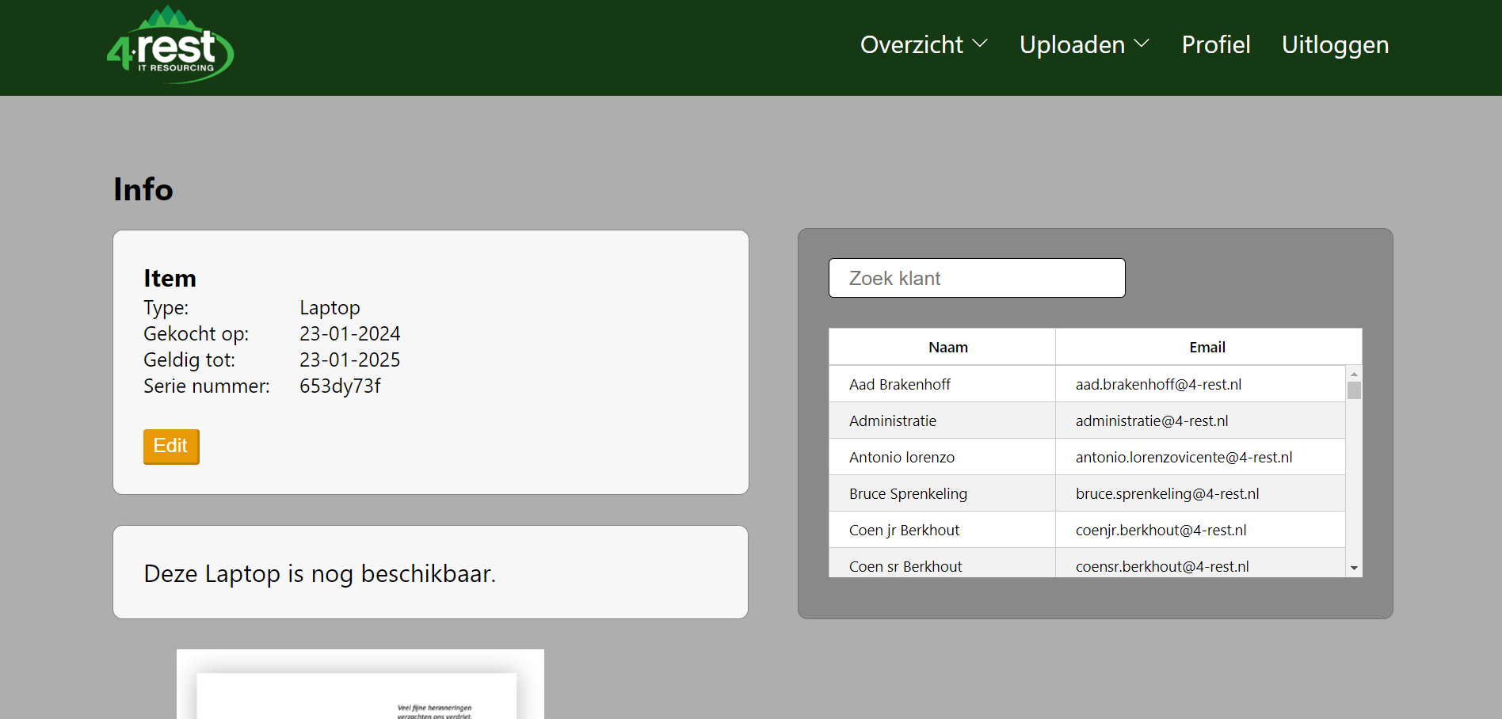

## 5.3. Return product

When you can lend a product to an employee you get to see the information of the employee which you have lent it to. To return the product you can click on "Laptop terugbrengen" and confirm this with the "Bevestig" button.

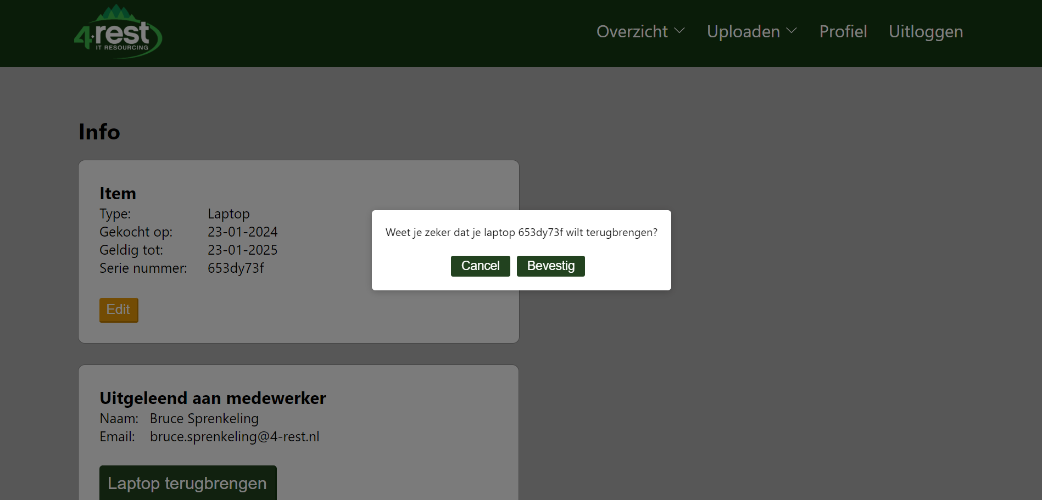

## 5.4. Upload

The following images shows where you can upload new products. To get here you need to hover over "Uploaden" and click on "Product".

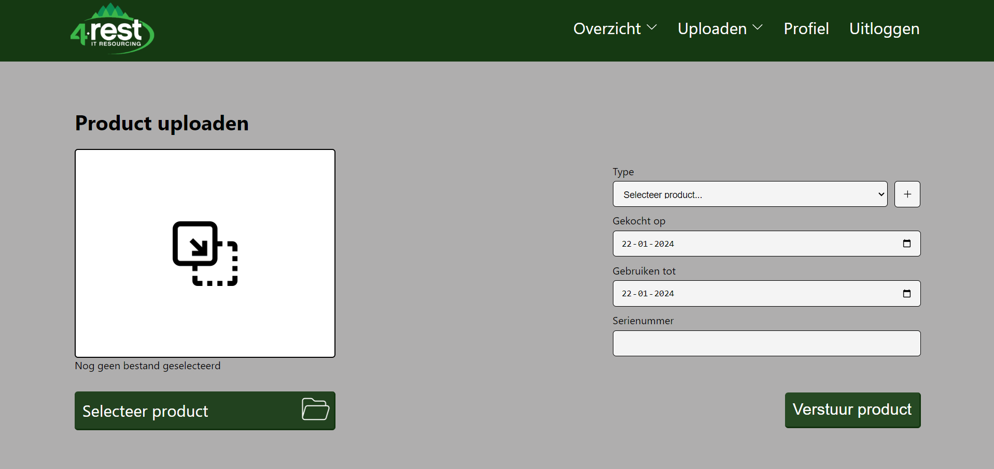

# Profile

## 6.1. Personal data

If you click on “Profiel” in the header, you will see this page. On this page you can view and edit your personal data.

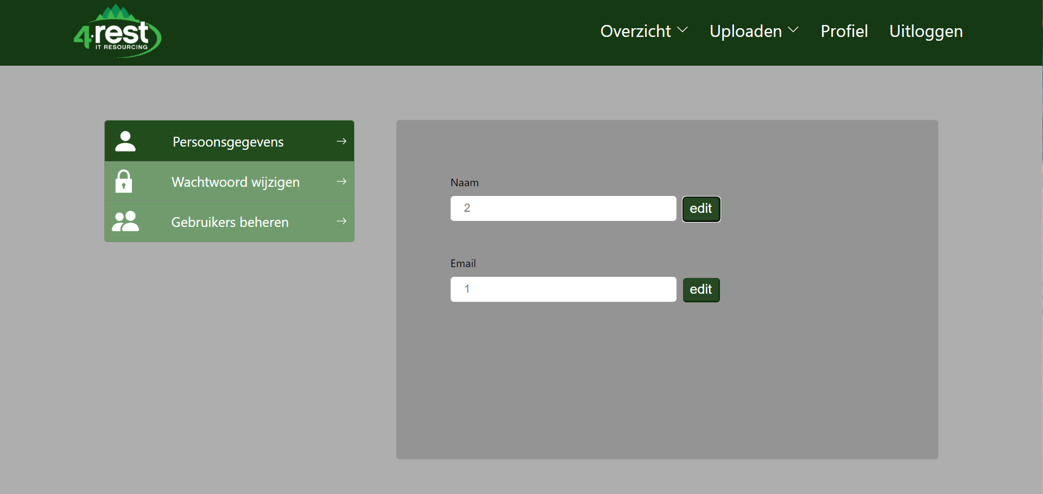

## 6.2. Edit data

When you click on “Edit” a new field fill appear. To edit it you need to fill the field and then click “bevestig”

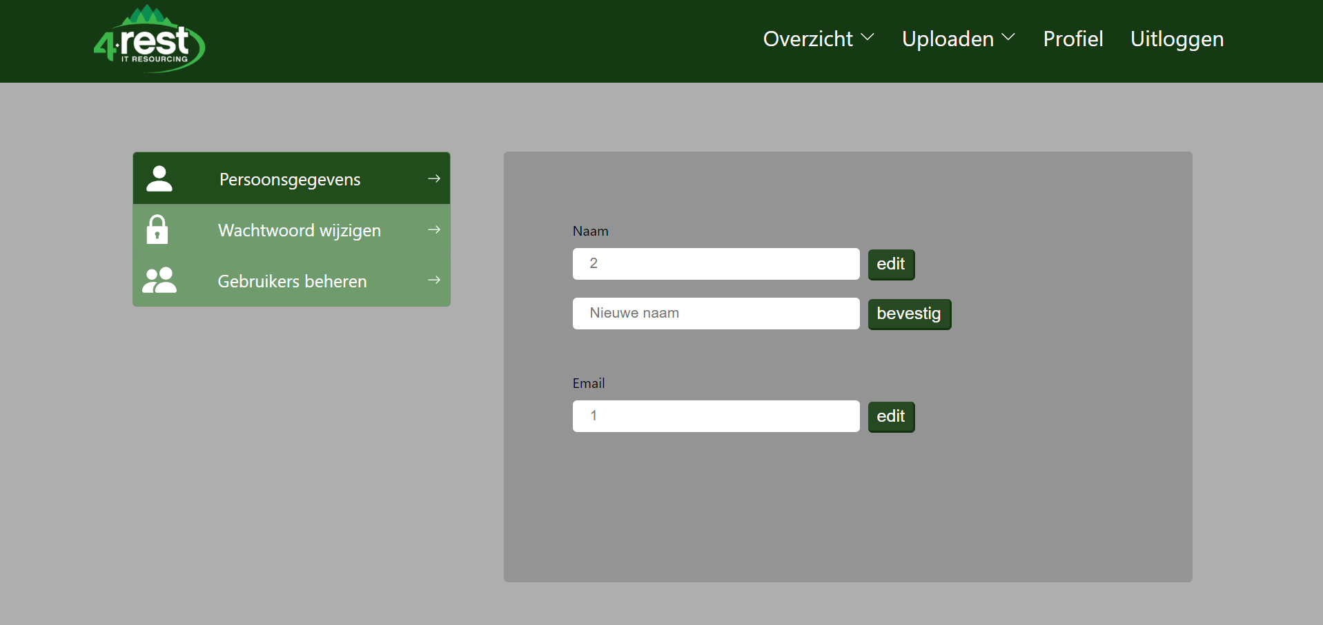

## 6.3. Change password

When you click on “Wachtwoord wijzigen” you can edit your password. First you fill in your currect password and then the new password 2 times. Lastly you click “Bevestig”

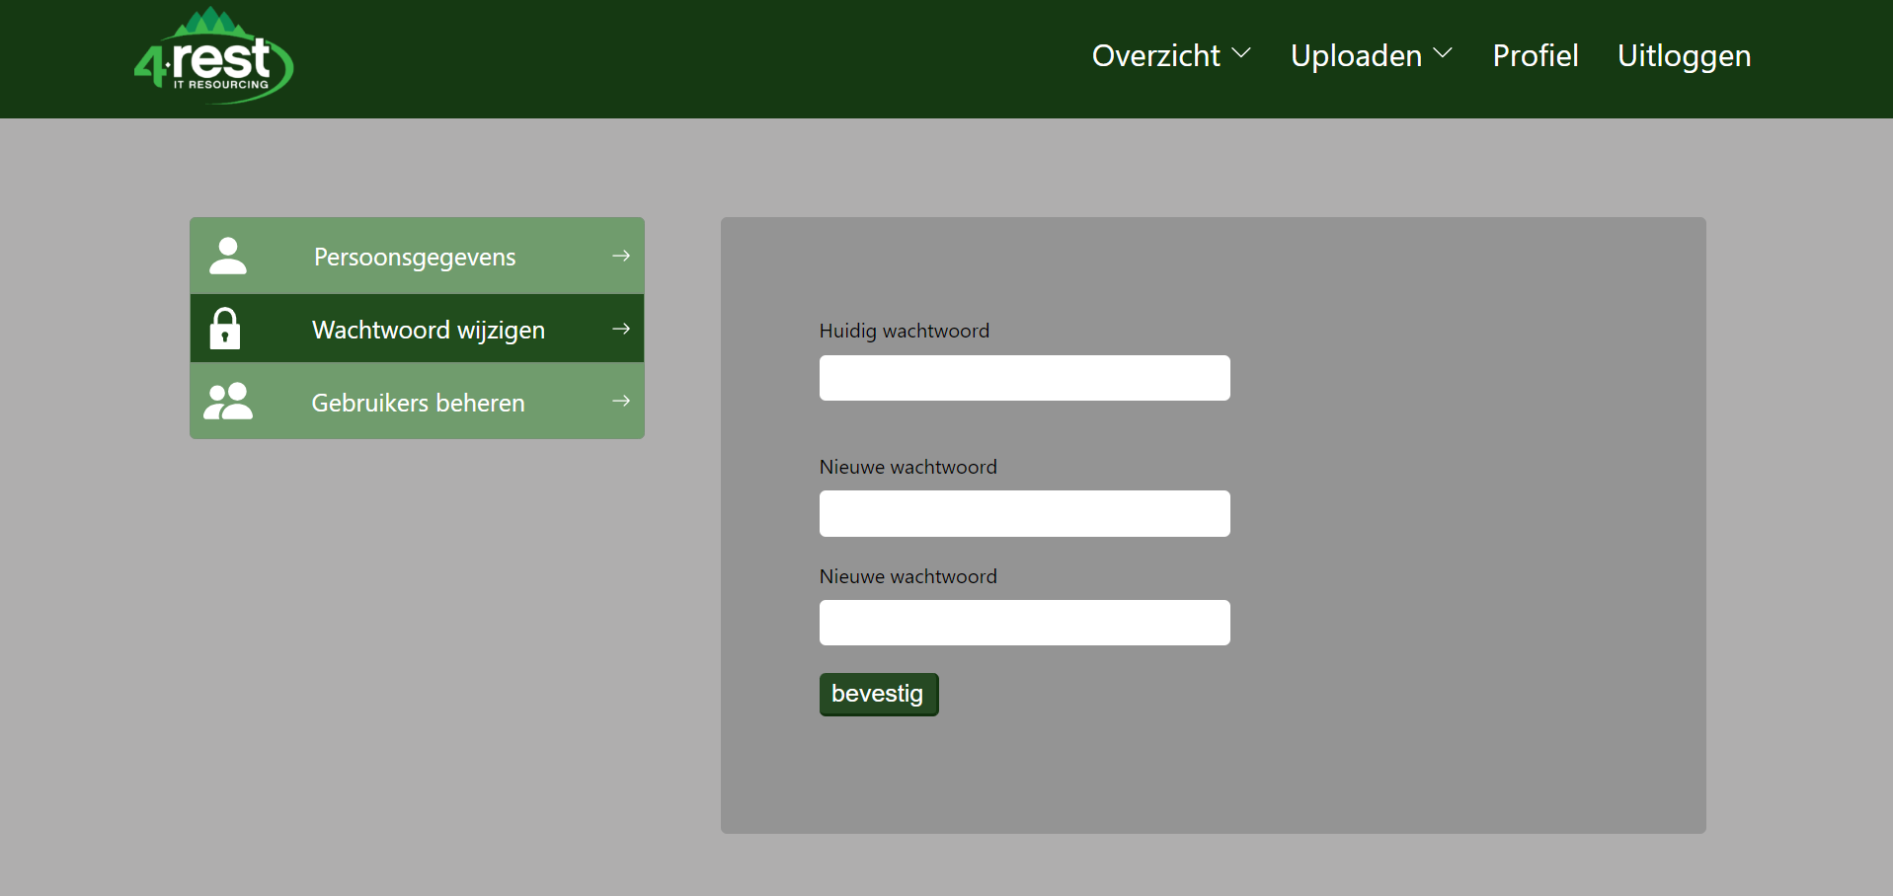

## 6.4. Manage users

When you clicked on “Gebruikers beheren” you arrive at a page where you can manage the users which can access this website. In the table you see all the users and you can delete users with the trash icon. If you click on the add user icon, you will be able to add a new user.

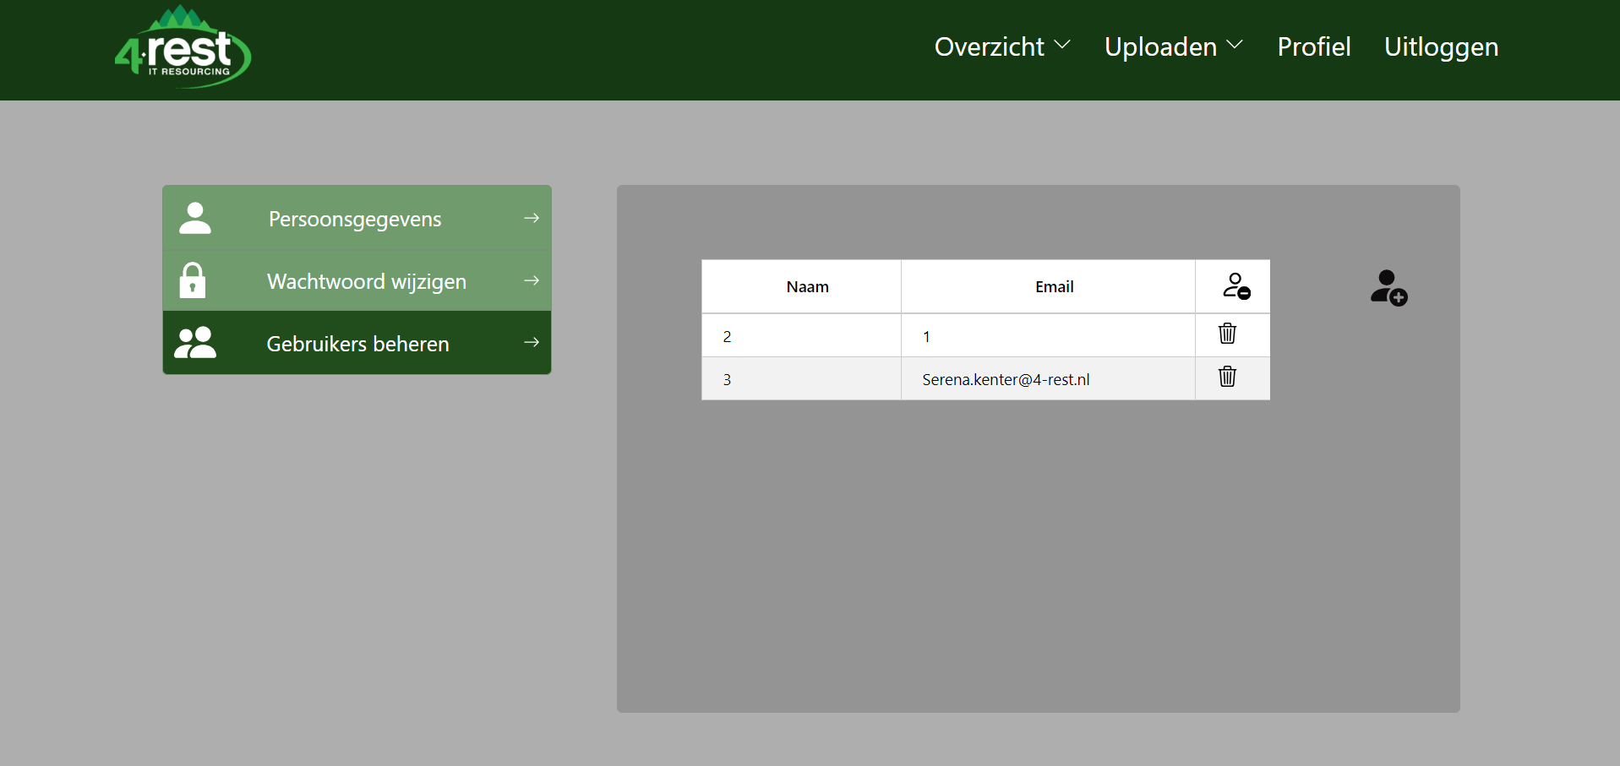

By pressing the “Uitloggen” button you are safely logged out.